Agenda Item: 10

Regular Board Meeting
September 26, 2022

Division News

With profound sadness, Greater St. Albert Catholic Schools joined the nation, the Commonwealth, and the world, in mourning the passing of Her Majesty, The Queen. May God’s presence strengthen and comfort the Royal Family, and indeed the world, during this difficult time. In solemn recognition of Her late Majesty, all schools within our division engaged in prayer, reflection and moments of silence to commemorate the passing of Queen Elizabeth II.

Many schools within the division gathered for welcome-back liturgies with many grade 4 students receiving their first bibles. Many thanks to all the parents, grandparents and family members who participated in the celebrations. We have Arose, we have gotten going and now we are preparing to Go with God this school year.

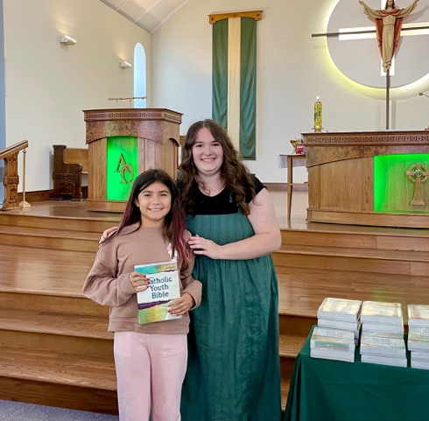

Congratulations to Msgr. Gary Franken has been appointed the new bishop of the Diocese of St. Paul and to Bishop Paul Terrio on his retirement.

What an incredible evening of connection, conversation, and engagement gratitude to Vincent J Maloney for hosting the 1st community tea and Bannock event! Community members, students, staff and families connected over tea and Bannock on Sept. 14 in the spirit of reconciliation.

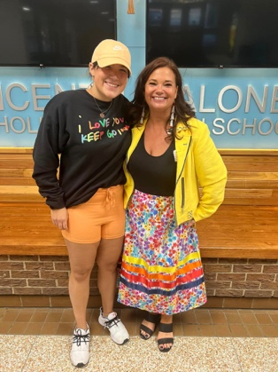

School News

Recreation Academy students from Sister Alphonse Academy have already participated in various group adventures including visits to the driving range, biking at Rundle Park and “hanging” out at the Snow Valley Ariel Park.

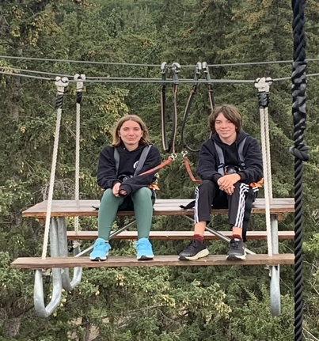

The SACHS Skyhawks Football team is off to a great start winning their season-opener at Larry Olexiuk Field on September 8th.

Please congratulate the Sr. Girls Volleyball Team from Morinville Community High School on their great start to the season. They played at King’s University where they came out of their pool in second place. Go Wolves!

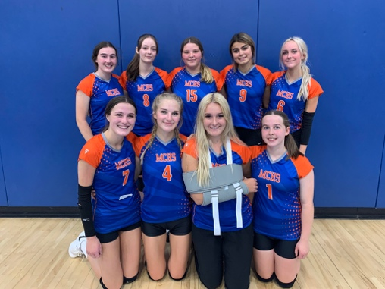

EFJ - ALL THE WAY! We are so proud of our students who represented Ecole Father Jan Community School last night during the first Fun Run of the year. Each student blew us away with their spirit, their determination and their effort during the event.

The Jaguars were also very excited to take part in the Terry Fox School Run earlier this month. Students raised $300 for cancer research through their Toonies for Terry fundraiser! Terry never quit on his dream of a world without cancer, and neither will we. Thank you for supporting our school in the fight against cancer and showing your no-quit attitude in honour of Terry!

It was an amazing day for the Bertha Kennedy Catholic School community! The school raised $1044.45 in support of cancer research! Just like Terry, students showed perseverance, enthusiasm, compassion, and teamwork! Many thanks to Hunter for kicking off the event and cheering on us as we crossed the finish line.

Congratulations to a St. Gabriel Education Centre alumnus, Maggie Slessor, who won a bronze medal in the Para-Athletics women’s 400m wheelchair race at the Canadian Summer Games in Niagara Falls. Way to go! We’re so proud of you and all your accomplishments!

We are excited to announce the first day of the Rec. Dynamic Options for Grade 4-9 at Legal School. All spaces are filled for the current school year, but we will open additional spaces for the next school year due to the overwhelming interest. Over 50 students have registered in the new program!

An art student from Ecole Secondaire St. Albert Catholic High School, Chantal Lafreniere, received a perfect score in AP Art. Advanced Placement Exams are scored on a scale of 1 to 5 and not only did Chantel receive the top score, but she was one of only 197 students in the world to accomplish this score! Congratulations!

Today, students from École Marie Poburan each painted one handprint onto a collaborative tree mural, making the colourful leaves for our trees. The mural was prepared by francophone Métis artist Jacques Martel. The finished product is now displayed on the school.

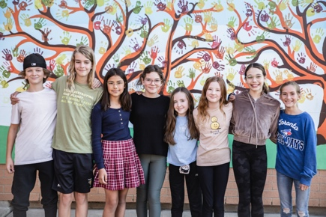

It was a very exciting day for students at École Father Jan Community School as they celebrated their annual house sorting ceremony. Each year, new kindergarten students partake in this ceremony to determine the house they will belong to while at the school. It is a magical day with so much excitement in the air.

