Agenda Item: 10
Division News

Earlier this month, at The Alberta Catholic School Trustees’ Association Awards Banquet, I had the distinct honour of presenting the Association’s Meritorious Service Award to former Trustee and colleague, Joan Crockett, a Trustee for 12 years.

Thank you for the media coverage! Schools throughout our division will soon be offering students free menstrual products in washrooms as a part of an initiative to remove barriers for girls within our division. We are pretty proud of this initiative! Thank you to Bertha Kennedy Catholic School teacher Leisa Michael for spearheading this project.
All of our schools gathered on November 10th to remember those who served and those who have fallen while serving our country. Thank you to everyone who helped with these ceremonies.
In Remembrance - Nous n’oublierons pas.
Halloween Fun was evident for all of our schools, students and staff! Below is just one of the many photos from our schools, featuring teachers from St. Kateri Tekakwitha Academy in coordinating Dr. Seuss costumes.
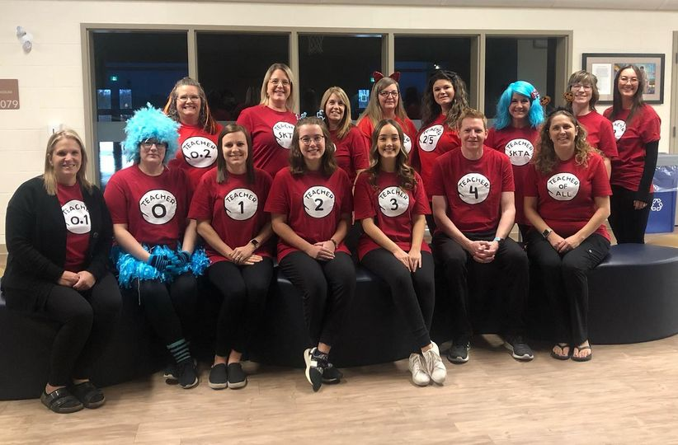

School News

This past weekend, the Ecole Father Jan Jaguars represented their school in the Mini Handball Provincials and they made us proud! Not only did they represent EFJ but they represented all of St. Albert as the only St. Albert team to participate. The Gr. 3/4 team and Gr. 5/6 team both finished in 4th place in their tournaments!! Amazing teamwork! Thank you to our coaches, Mme Jurick and M. Holstein, for all of the practices and the fantastic leadership on the day of the tournament.
It was a very proud moment for the Richard S. Fowler Falcons last weekend as they won the Tier 2 Boys Volleyball City Championships! Thank you to the amazing fans for your school spirit!
Please congratulate the Morinville Community High School Senior Boys Volleyball team on winning Bronze at zones in Westlock earlier this month. Way to go Wolves we are proud of you all.
The Ecole Marie Poburan Kindergarten students had so much fun at their field trip to the Musée Héritage where they learned about Métis weaving. It was a beautiful opportunity to learn about Métis culture and tradition. Maarsii! Bravo les amis!
Students from Holy Family Catholic School cross graded learning about and creating Wampum belts for Métis week. Connecting to the land and important things in their lives.
A group of Skyhawks travelled to Jasper last weekend to take part in the Jasper Dark Sky Festival! It was a fantastic opportunity to get away, connect with the land, and take some awesome photos!
Students from Sister Alphonse Academy have been participating in their own FIFA World Cup tournament, while the world watches the current World Cup in Qatar. As students participate in the tournament, they are also raising money for Catholic Social Services. Parents and students are invited to lunchtime and recess games and the school spirit is through the roof!

The senior girl's Volleyball team with École Secondaire Sainte Marguerite d'Youville won the Tier 2 final earlier this month. Congratulations!

CONSENT & ACTION ITEMS

The following Action items were approved:

13.1. 2021-2022 Audited Financial Statements (Paulik)
13.2. Policy 15: School Closure (Moroziuk)

SUPERINTENDENT’S REPORT

- 15.2.1. Educational/Interagency Partnerships Report (Giesbrecht)

NEXT REGULAR BOARD MEETING

The next Regular Board meeting is scheduled to take place on December 12, 2022, at 3:30 p.m.

